IDPA Classification Match Score Sheet
Breakdown of Classification Scores
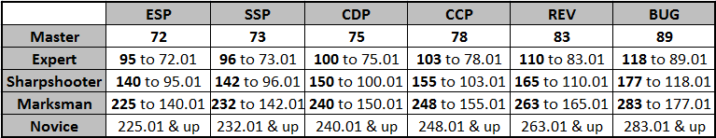

STAGE ONE (24 Rounds Total, 8 Hits per Target Required) String 1 __________
String 2 __________
Hits per Target String 3 __________
T1 T2 T3 Procedurals x 3 __________
Points Down per Target Points Down x 1 __________
T1 T2 T3
Stage Three Total

STAGE TWO (24 Rounds Total, 8 Hits per Target Required)
String 1 __________
Hits per Target String 2 __________
T1 T2 T3 String 3 __________
Points Down per Target Procedurals x 3 __________
T1 T2 T3 Points Down x 1 __________
Stage Two Total
STAGE THREE (24 Rounds Total, 8 Hits per Target Required)
String 1 __________
Hits per Target String 2 __________
T1 T2 T3 Procedurals x 3 __________
Points Down per Target Points Down x 1 __________
T1 T2 T3
Stage Three Total
Name: ______________________________ IDPA # ________________
Address: ___________________________________________________
City: _______________________ State: ______ Zip: ________________ Match Total
E-mail: ____________________________________________________

CDP ESP SSP CCP REV
MA EX SS MM NV

